Software Requirements Specifications

for

Alaska Trails

Version 3.0 Approved

Prepared by Jonathan Jeans
Joseph Fiskeaux

Alaska Trails

Feb 25, 2018

Table of Contents

Table of Contents 1
Revision History 2
1. Introduction 3
1.1 Purpose 3
1.2 Document Conventions 3
1.3 Intended Audience and Reading Suggestions 3
1.4 Product Scope 3
1.5 References 3
2. Overall Description 4
2.1 Product Perspective 4
2.2 Product Functions 4
2.3 User Classes and Characteristics 4
2.4 Operating Environment 4
2.5 Design and Implementation Constraints 4
2.6 User Documentation 5
2.7 Assumptions and Dependencies 5
3. External Interface Requirements 5
3.1 User Interfaces 5
3.2 Hardware Interfaces 6
3.3 Software Interfaces 6
3.4 Communication Interfaces 6
4. Project Features 7
4.1 Set view current events of Anchorage trails 7
4.1.1 Description of Events and Priority 7
4.1.2 Stimulus/Response Sequence 7
4.1.3 Functional Requirements 7
4.2 Map to view current events and Anchorage trails 7
4.2.1 Description of map, features, and Priority 7
4.2.2 Stimulus/Response Sequence 7
4.2.3 Functional Requirements 8
4.3 Add login to current site 8
4.3.1 Description of Login and Priority 8
4.3.2 Stimulus/Response Sequence 8
4.3.3 Functional Requirements 8
4.4 Clean up site and update theme 8
4.4.1 Description of Clean up, site updates, and Priority 8
4.4.2 Stimulus/Response Sequence 8
4.4.3 Functional Requirements 9
4.5 Add map of entire state hiking trails 9
4.5.1 Description of State map and Priority 9
4.5.2 Stimulus/Response Sequence 9
4.5.3 Functional Requirements 9
5. Other Nonfunctional Requirements 9
5.1 Performance Requirements 9
5.2 Safety Requirements 10
5.3 Security Requirements 10
5.4 Software Quality Attributes 10
5.5 Business Rules 10
6. Other Requirements 10
Appendix A: Glossary 10
Appendix B: Analysis Models 11
Appendix C: To Be Determined List 11
Document Review 12

Revision History

Name | Date | Reason for Changes | Version
Joseph Fiskeaux | 2/25/2018 | Updated Document with Images and References | 3.0
Jonathan Jeans | 2/25/2018 | Updated Project Images with Peer Reviews | 3.0
Joseph Fiskeaux | 2/18/2018 | Peer Revision Update | 2.0
Jonathan Jeans | 1/31/2018 | Initial Draft | 1.0
Joseph Fiskeaux | 1/30/2018 | Initial Draft | 1.0

1. Introduction

1.1 Purpose
Version 3.0 Release 1.0
The purpose of this project is to update the current look and feel of the Alaska Trails website. Our team will be adding event functionality for users, creating a signup/login page, and implementing a map that allows users to see locations of events and Anchorage trails.

1.2 Document Conventions
When creating this document, size sixteen headers were used to break up the document into sections. The eleven headers are used to describe specific features in those sections.

1.3 Intended Audience and Reading Suggestions
This document is intended to be viewed by the project manager, Steve Cleary, testers/users at Alaska Trails, and programmers Jonathan Jeans and Joseph Fiskeaux. This document is broken up into the following categories: Introduction, Overall Description, External Interface Requirements, Project Features, Other Nonfunctional Requirements, Other Requirements, Appendix A, Appendix B, and Appendix C. Suggested reading for project manager and testers/users: Overall Description and Project Features.

1.4 Product Scope
To implement a website that is more user friendly and functional. This includes cleaning up the existing site by updating look and fixing some header issues, implementing an event database that allows users of the site to join upcoming events, creating a signup/login form for new and existing users, and creating a map that will display event locations as well as a small profile and hyperlink to the existing event page.

1.5 References
http://www.alaska-trails.org/
http://www.weebly.com
https://www.google.com/sheets/about/

2. Overall Description

2.1 Product Perspective
The product being updated by the stated changes is a newly published website. All changes will affect the overall website by adding a login, creating a map of events, and creating a page for events. The user creation form will allow users of the website access to certain regions of the website that non-users will not be able to access. This will affect various clickable regions of the website that will link to the events, so a redirect will need to be implemented that requires non-users to sign-in or sign up for the Alaska Trails services.

2.2 Product Functions
- Admin users will be able to add events and specify a time, place, bio, and maximum occupancy.
- A login/sign up form will be created that allows users of Alaska-Trails.org to join events as well as see where upcoming events will be located.
- A map that allows users to view the locations of upcoming events.
  - If time permits, all Anchorage trails will be added to the map.
- Cleaning up the overall look and feel of Alaska-Trails.org.

2.3 User Classes and Characteristics
Admin users will need to maintain the website. This includes: adding new material and events to finished product, testing changes before publishing new changes, and having peers look over completed changes.

2.4 Operating Environment
The product being created will be implemented through Weebly, a Content Management Service (CMS) provider, and will be available to anyone with internet access.

2.5 Design and Implementation Constraints
Weebly only allows programmers to use embedded code blocks within their website builder. This restricts the programmers to only using HTML, CSS, and JavaScript. There is also no backend support through Weebly so some database features will have to be implemented through the use of Google Sheets, an online spreadsheet tool.

2.6 User Documentation
Programmers, Jonathan Jeans and Joseph Fiskeaux will create a user manual for adding new events to the website as well as their correlated map locations. There’s a possibility the admin user will have to add the locations manually to the Google Sheets document if the Google API does not allow the programmers to embed code that completes the task automatically.

2.7 Assumptions and Dependencies
Google Sheets - database is dependent on using this open source software for backend development. Without it, events will not be possible to maintain.

Leaflet - this is an open source JavaScript program that allows CMS users to add maps to existing sites. If programmers are unable to add required features to this tool then another piece of software will need to be used for this aspect of the site.

User sign up/login - this is solely dependent on Weebly. If anything were to happen to Weebly as a company and they no longer offered the ability to add user functionality to the website, then Alaska Trails would lose their client base.

3. External Interface Requirements

3.1 User Interfaces
Login/Sign up Page: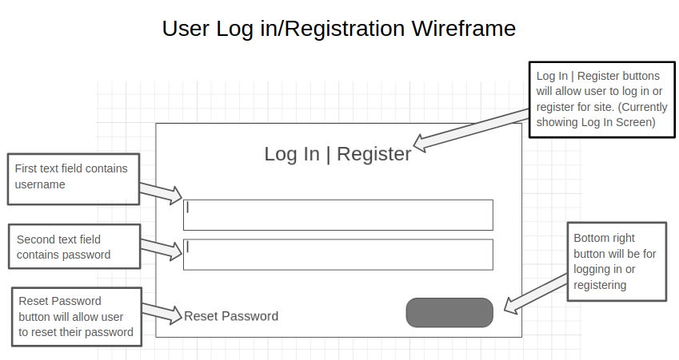
Figure 1: Log In/Registration
- On the far-right side of the navigation bar will be a button that reads, “Login/Sign Up”.
  - When clicked on, user will be directed to a login page that also has a button for signing up for Alaska Trails services. If sign up button is clicked then user will be directed to the signup form and will be given their user information.
  - There will be a reset password button shown in figure 1.
Events Page: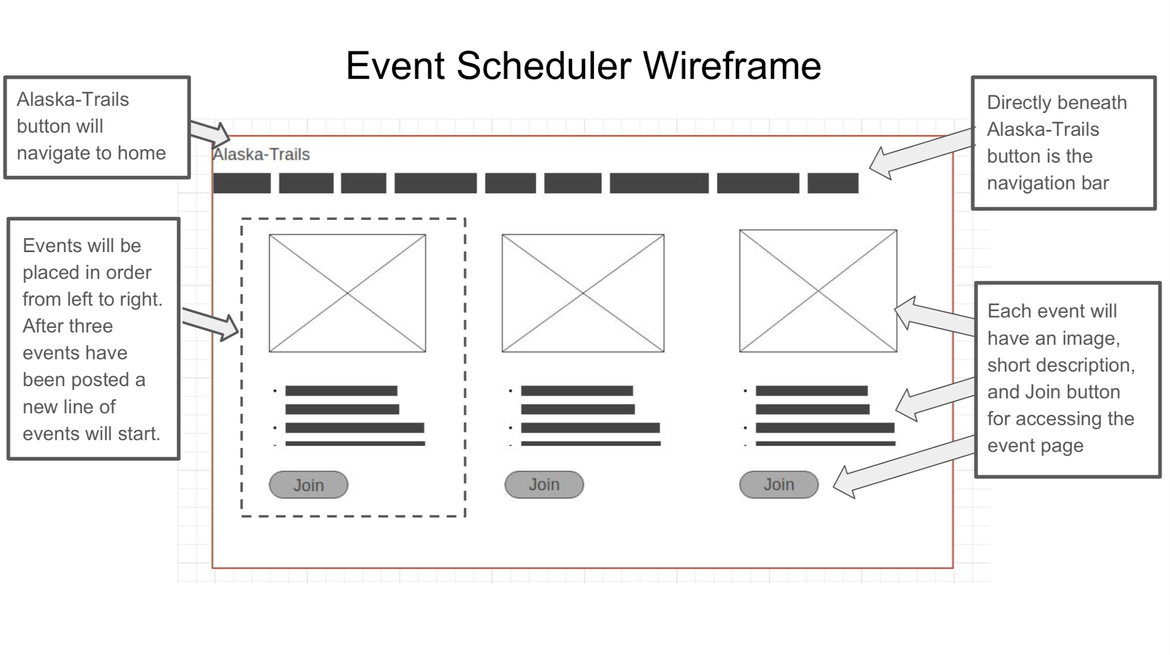Figure 2: Event Scheduler
- There’s already an existing Events button in the navigation bar, so the programmers will add another option in the drop-down selection that reads, “Join Events”.
  - When clicked on, the user will be directed to an events page that lists upcoming events that are listed earliest to latest.
- Each events page can have an image, short bio, date, as well as a “Join Event” button shown in figure 2.
  - If the user is already logged in then they will be notified that they have joined the event. However, if the event is already at maximum capacity then the user will be added to a waitlist.
  - If the user is not logged in then they will be redirected to the Login/Sign up page.
- There will also be a map button that allows the user to view the location of the event.
  - This will redirect the user to the map page, that the programmers will create, and allow them to see the location of their event.

Map page: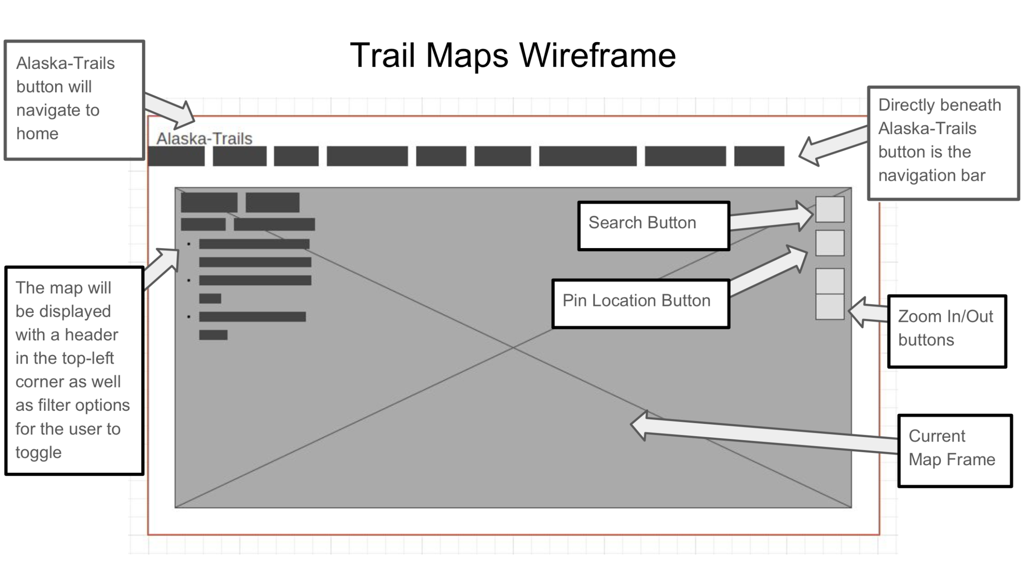Figure 3: Trail Maps
- The user will navigate to the map page through a button that is located in the navigation bar shown in figure 3.
  - The original map will have pinpoints for each location that an event can be found. When a pinpoint is clicked on, a short bio will appear as well as a link that takes the user to the event page.
  - If time permits, additional trail features will be added to the map. These features will allow users to view all Anchorage Trails, as well as a short bio.
Cleaning up the Website:
- The homepage needs to be more inviting.
  - Programmers will add more features that navigate to various regions of the site. This will include links to events, map, and about.
  - The navigation bar needs to be reworked so that the user is not required to click on the menu button, currently in use, to see the rest of the navigation bar.
- Many minor things as well, such as moving content around, creating a more user friendly experience, fixing the page borders, and fixing some alignment issues on some of the pages.

3.2 Hardware Interfaces
- Users will need some form of a computer in order to access the website.
  - PC, tablet, smartphone, etc.

3.3 Software Interfaces
- Product is a website, so it’s available to anyone with access to the internet.
- Programmers are limited to only using CSS, HTML, and JavaScript.
- Leaflet, an open source JavaScript program for mapping, will be used to implement the maps used on the website.
- Backend will be dependent on Google Sheets.

3.4 Communication Interfaces
- The website will need to be accessed using a web browser, such as Chrome, Edge, Safari, or Firefox.
- The website will communicate with Google Sheets using HTTP.

4. Project Features

4.1 Set view current events of Anchorage trails

4.1.1 Description of Events and Priority
Events will be listed on an events page where users can browse what events they would like to sign up for. As a part of events the client will be able to create events and track how many people have registered for an event. This feature is a top priority.

4.1.2 Stimulus/Response Sequence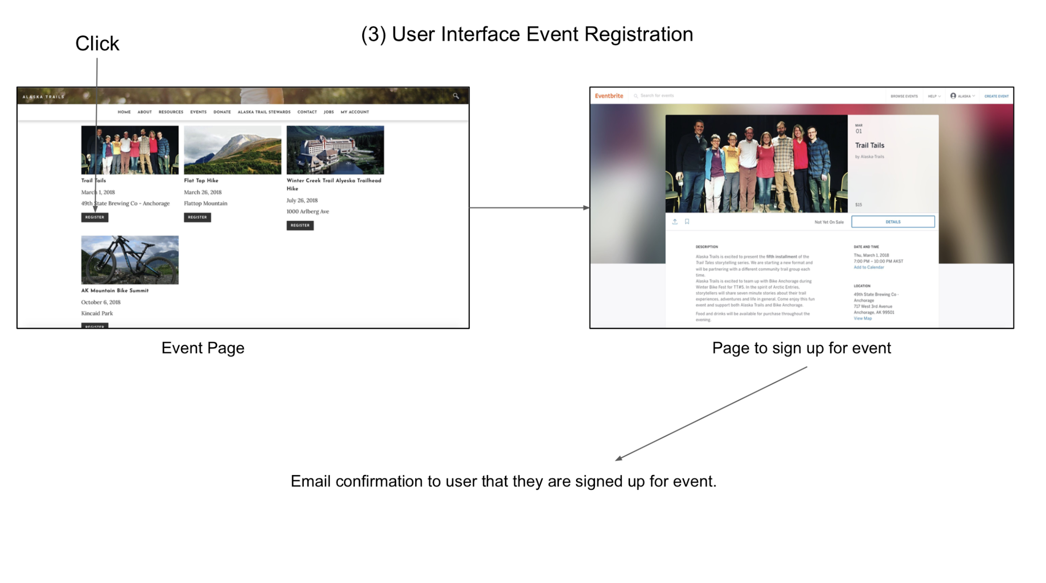Figure 4: Events Interface
For this feature the user will be interacting with a grid pattern list of events where they can select what event they would like to look at by clicking on it. Once the event is clicked a link to eventbrite will be opened with that event. Figure 4 above shows the breakdown of how the user would go thought the steps of signing up for an event.

4.1.3 Functional Requirements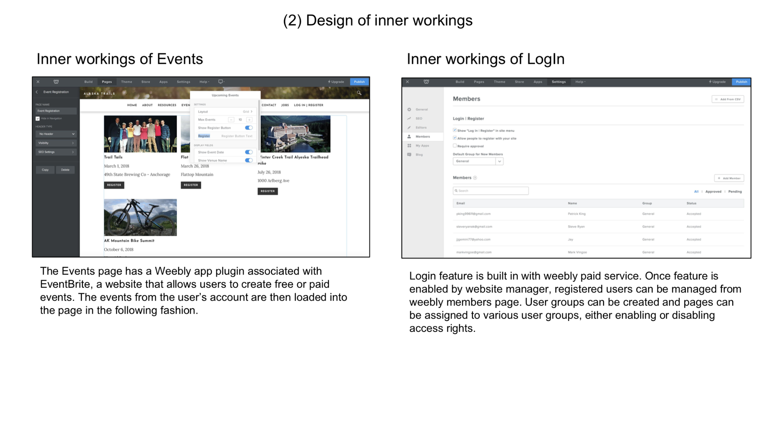Figure 5: Inner workings of Events
Events will have to be saved to their own pages on weebly. We will need a form that takes users name, and contact information. When the form is complete it will need to send confirmation email to client to show user has signed up. On the web site there is manager for the event view shown in figure 5.

4.2 Map to view current events and Anchorage trails

4.2.1 Description of map, features, and Priority
The goal of this feature is to add a map that will let you view hikes at locations around Anchorage and see what events are currently planned for these locations. Once you have found an event for a hike you would like to join you can open the event and sign up for it. This feature would be an extension of the events feature. Adding this gives the users another means of finding and joining events. It would also give the user a way of knowing the location of their event. This feature is a medium priority.

4.2.2 Stimulus/Response Sequence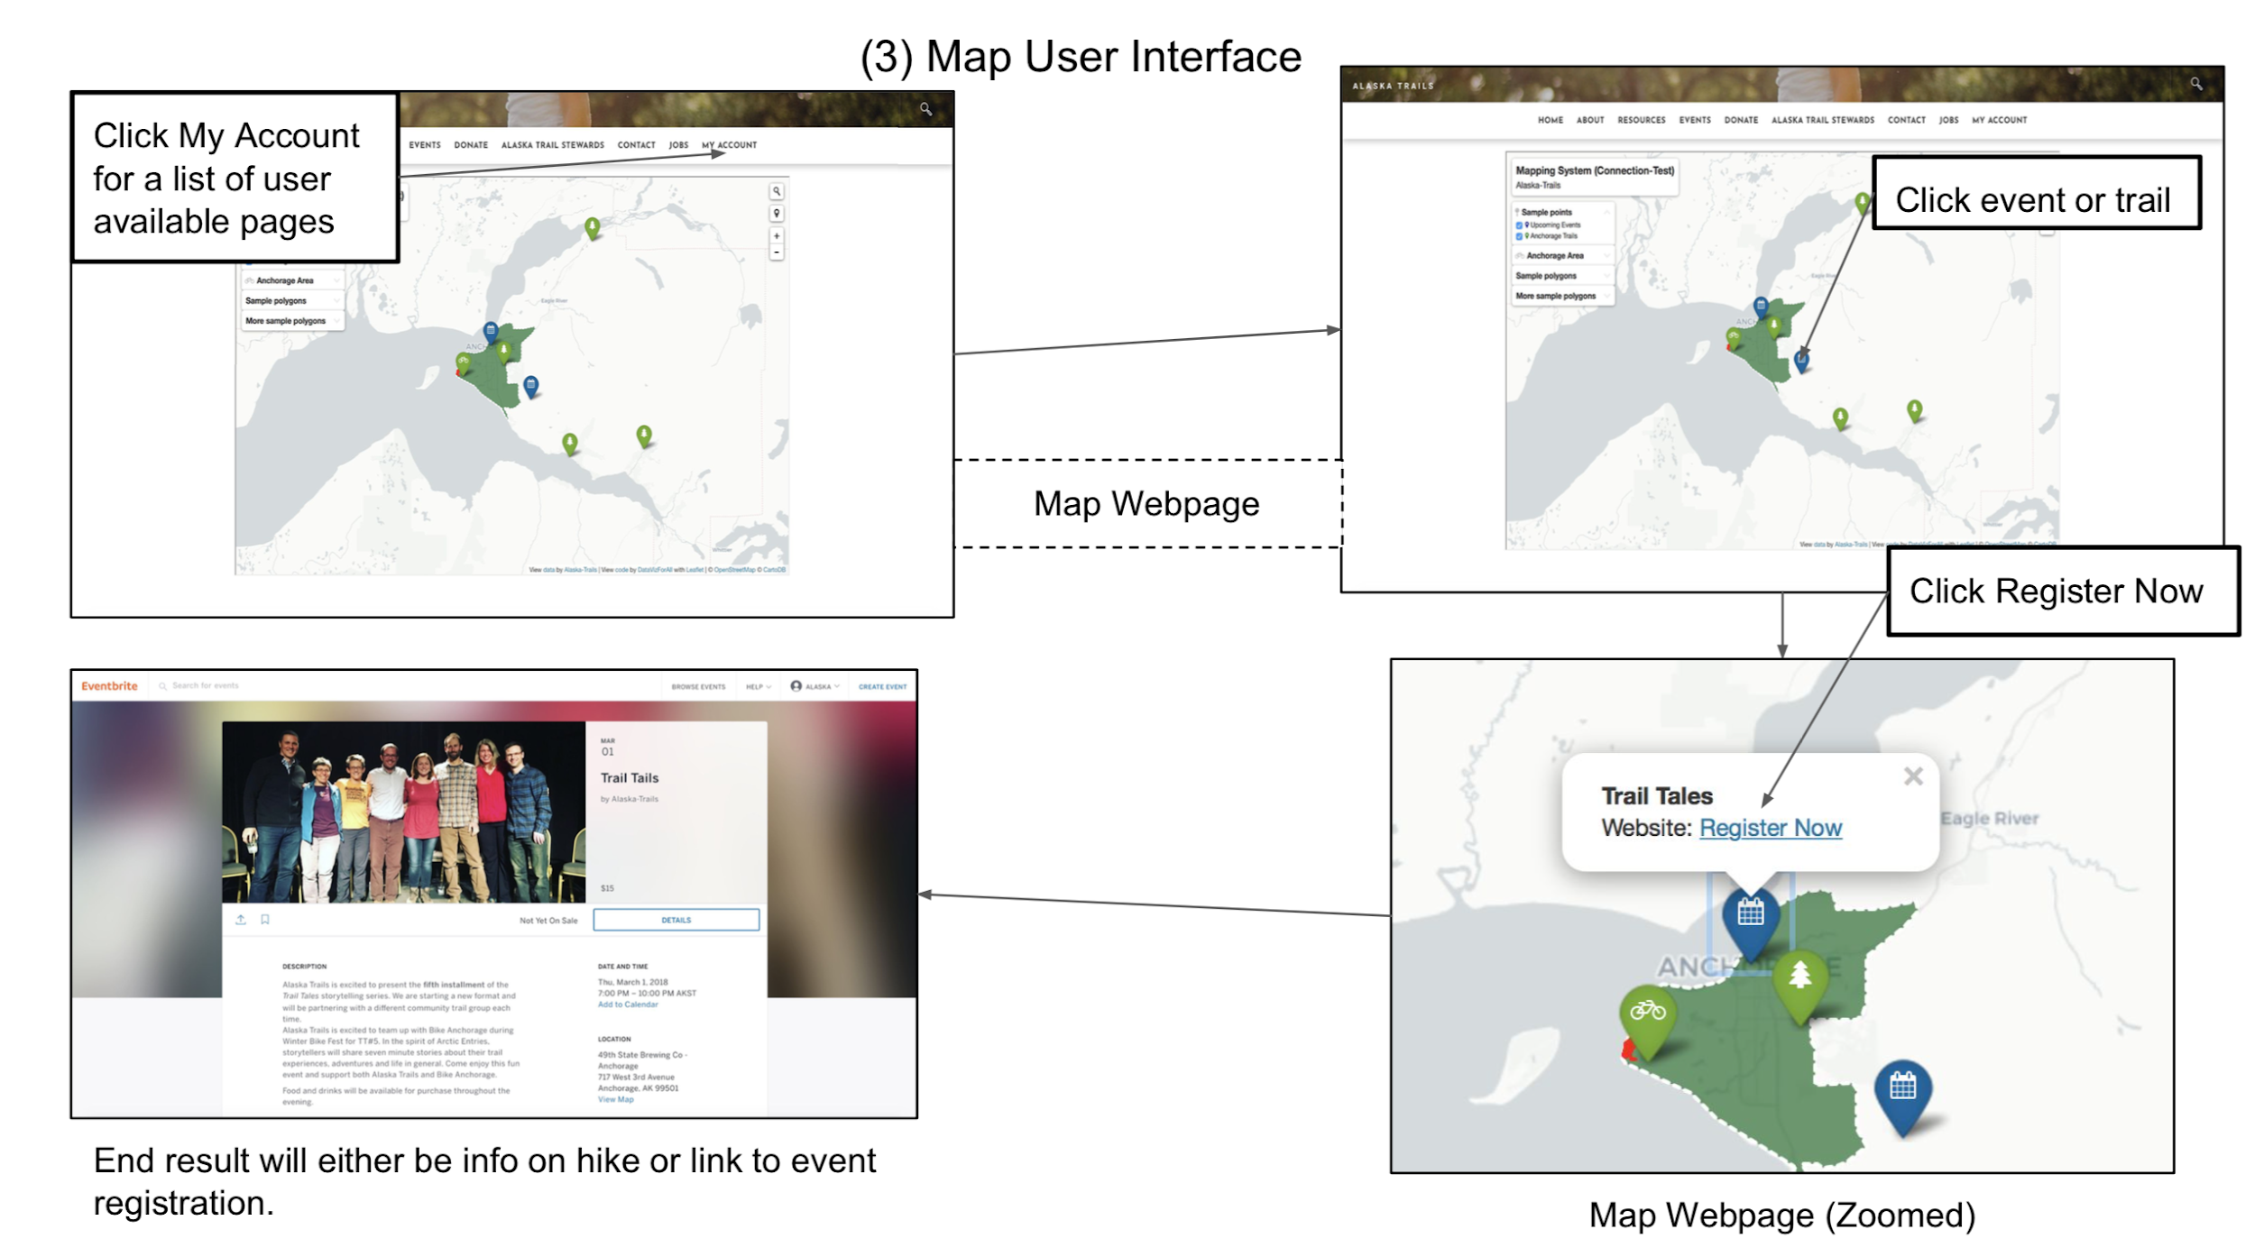Figure 6: Map User Interface
This features will be an interactive map that they can click on and drag their view around in the same way google maps works. There will be event markers that are clickable. Once event is clicked it will link user to event where they can register, shown in figure 6.

4.2.3 Functional Requirements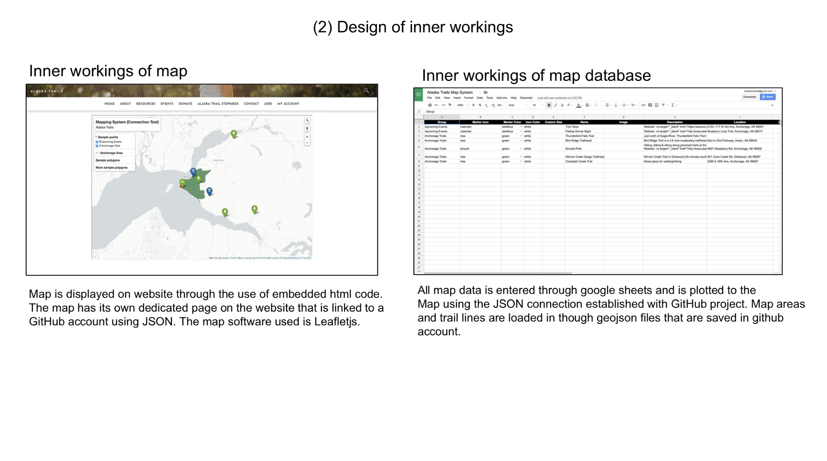Figure 7: Inner workings of map
For this feature the required functionality is the map must load saved events. We will need to make client google account because It needs to be linked to google sheets to get information on hikes and to set hike event parties. Map will need to be updated through google sheets for changes to be made. Figure 7 shows an example of how the google sheet can have saved events and trails that can be loaded into a map.

4.3 Add login to current site

4.3.1 Description of Login and Priority
The log in will let users sign in to their accounts as well as create accounts. It will be a way to let new users join the site as well as support existing users. The login will also let users sign up for Alaska Trails membership. This feature is a top priority.

4.3.2 Stimulus/Response Sequence
Form page will have text boxes that user can click on and tab through when they make their account. There will be text boxes for login page as well.

4.3.3 Functional Requirements
The log in will have a button to sign up for an account. It will have a page that lets you log in and a feature that will let the user click a button at sign up that will sign them up for an alaska parks membership. The admin will also be able to manage the users that have registered on the site shown in figure 5.

4.4 Clean up site and update theme

4.4.1 Description of Clean up, site updates, and Priority
Cleaning up the site will make the site more user friendly and pleasing to the eye. It will fix some pages that have dead end content and or delete them. We will also be updating the site with new pictures and theme. This feature is a high priority.

4.4.2 Stimulus/Response Sequence
Site drop down will be changed so drop down can be seen and clickable without clicking menu button. All tabs will be clickable. Any links that are clickable will be intuitive to the user.

4.4.3 Functional Requirements
Functional requirements will be to change the theme in Weebly themes, update website functionality of menu button, update pictures on website, and update splash page to something more aesthetically pleasing.

4.5 Add map of entire state hiking trails

4.5.1 Description of State map and Priority
The map will be a page on the website where users can look at different hikes they could go on for the entire state. The hikes will be marked on the map and will be clickable. Once clicked they would display information on the hike you are looking at like how long it is, what to bring, conditions, etcetera. This feature is a low priority. It will be the last thing we do.

4.5.2 Stimulus/Response Sequence
This features response to the user will be an interactive map that they can click on and drag their view around in the same way google maps works. There will be clickable trails.

4.5.3 Functional Requirements
Map needs to load on website. We will need to add all hikes to map from all around the state. Possible requirement could be importing these trails from a map that already has trail locations marked.

5. Other Nonfunctional Requirements

5.1 Performance Requirements
The map should run in linear time, but could be delayed when loading due to the fact that locations will be maintained in a Google Sheets database.
There will need to be a function for each individual event that determines whether the current user is already enrolled in the event. This will be used to determine what button is displayed, either “Join Event” or “Leave Event”. This should also run in linear time.

5.2 Safety Requirements
The Google Sheets data will need to be backed up in another spreadsheet on a local device at Alaska Trails. This will help prevent the loss of any event and/or map data due to an error with Google Sheets or due to user error.

5.3 Security Requirements
User data will be maintained by Weebly and programmers will only need to save users email addresses to the Google Sheets database. These email addresses will be used to maintain the Events tables in the database.

5.4 Software Quality Attributes
The main goal is to create a website that can be easily maintained by the workers at Alaska Trails. The website should include all of the specified features in a way that allows the Alaska Trails workers to add future events without having to do any coding. The workers need to also be able to maintain the database without writing any queries, so a detailed manual will be written explaining how to add and remove things from the database.

5.5 Business Rules
This product will be operated and maintained by Alaska Trails employees.

6. Other Requirements
Once the product is delivered, Alaska Trails will be responsible for maintaining the website as well as the database for their current/upcoming events and trail map locations. (This is subject to change if the programmers are able to embed code that allows an admin user to add and remove database data from the website).

Appendix A: Glossary
- CMS - Content Management Service
- CSS - Cascading Style Sheets
- Database - a structured set of data held in a computer, especially one that is accessible in various ways
- Embedded Code Blocks - An aspect of the Weebly development toolkit that allows programmers to add code to an existing site
- Google Sheets - a web-based spreadsheet program
- HTML - Hypertext Markup Language
- HTTP - Hypertext Transfer Protocol is an application protocol for distributed, collaborative, and hypermedia information systems
- JavaScript - a high-level, dynamic, weakly typed, prototype-based, multi-paradigm, and interpreted programming language
- Pinpoint - a tiny dot or point

Appendix B: Analysis Models
Entity Relationship Diagram (ERD) is in progress. This diagram will be used to show the relationships between the various tables in the database.

Appendix C: To Be Determined List
As of now, the only feature that is currently questionable is the state of Alaska map that will show all available hikes in the state. Due to the selection of Google Sheets as a database tool, the programmers may not be able to implement something that requires such a large amount of data. The feature may need to be scaled down to certain areas of Alaska.

Document Review

Name | Date | Comments

